Ecospace spatial‐temporal data framework a brief users’ guide

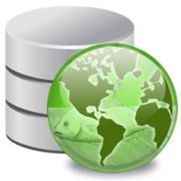

Version 1.3, 15 December 2021
Compatible with Ecopath with Ecosim version 6.7 α1
Jeroen Steenbeek, EwE dev team
Ecopath International Initiative, Spain

Contents
Purpose 2
Availability 2
Using the Spatial Temporal Framework 3
Connections 3
Assigning external data to Ecospace 6
Running Ecospace with external data 8
Configuration files 9
Sharing external data between computers 10
References 11

Purpose
This document provides guidelines for configuring, and running external time series of maps in Ecospace, the spatial‐temporal module of the Ecopath with Ecosim (EwE) food web modelling approach. This document was last updated December 2021 to EwE version 6.7.0.0 Alpha release.

Availability
The spatial temporal data framework is permanently under development, and is only available under an EwE professional license to support the ongoing efforts. For more information about licensing, please refer to https://ecopath.org/go‐pro.

Using the Spatial Temporal Framework
The spatial temporal framework is a plug‐in to the Ecopath with Ecosim food web modelling approach (Christensen and Walters, 2004; Heymans et al., 2016; Steenbeek et al., 2016), built with the sole purpose to dynamically insert (time varying) spatial data that is external to the EwE model into Ecospace map layers (Steenbeek et al., 2013).
The framework integrates with the EwE6 user interface in several locations (Figure 1).
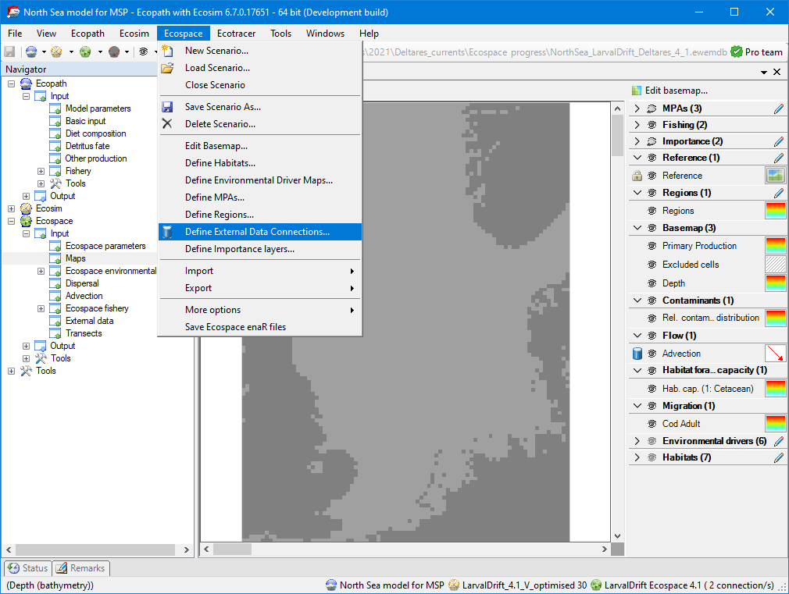
3
2
1
Figure 1 ‐ The EwE6 user interface, with indications to the presence of the external spatial data facilities: (1) an item in the EwE navigation tree, (2) a configuration option in the Ecospace menu, (3) a blue database icon beside each map layer in the Ecospace map interface to indicate this layer is connected to external data, and (4) a the number of external data connections summarized in the EwE status bar.

Managing external data connections
A ‘connection’ is the link between an Ecospace map layer and a repository of maps (or time series of maps) that are not stored within the EwE model (Steenbeek et al. 2013).
Connections are defined by the EwE user, and can be shared across computer systems and between users.
Connections are managed from the central “Define external spatial temporal connections“ screen (Figure 2), which is accessible from several locations in the EwE interface (see Figure 1). In this screen, users can create and delete connections of different types, export connections and their data for sharing across computers, and control whether the framework is allowed to dedicate background processing time to index the spatial and temporal overlap of external data with the current Ecospace scenario.

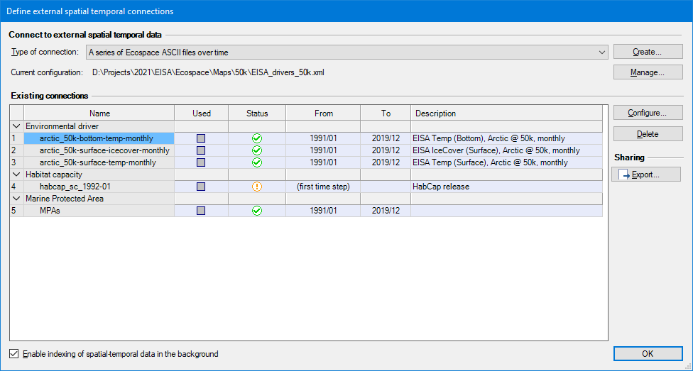
Figure 2 - Define external spatial temporal connections screen
This screen provides an overview of all defined external data connections, and summarizes their content. The “Used” column states if the connection is actually applied to one or more Ecospace layers (and cannot be edited here). The “Status” column uses icons to explain whether the connection has errors (), has only partial spatial overlap with the modelled area (), or entirely covers the modelled area (). The warning icon is also used to notify that data compatibility has not been assessed yet, which can be done by enabling indexing or by running Ecospace, in case each used connection is automatically validated.
The “From” and “To” columns specify the data range of the external data, more about that below. The “Description” column provides any notes that a user added when defining the data.
To index external datasets in the background:
- In the Define external spatial temporal connections screen (Figure 2), check the “Enable indexing of spatial temporal data in the background” option.
- To disable indexing, uncheck this option.
To define a new connection:
- Go to Menu > Ecospace > Define external data connections…
- Select the type of connection to create. At time of writing, four file‐based connection types are supported: (1) a time series of ASCII files which must be prepared to match the spatial extent and cell size of a dedicated Ecospace scenario; (2) a time series of spatial files which will be made fit for inclusion in Ecospace by the DotSpatial / GDAL GIS engine encapsulated in the spatial temporal data framework; (3) a file with X,Y,Z,T time series values provided in CSV file format, where (X,Y) coordinates can either indicate (column, row) or (longitude, latitude); and
- (4) a single spatial file.
- Press Create…. A new connection is defined, and the “Configure external data connection view” opens up (Figure 3) to allow its content to be modified.

Note that EwE plug-ins such as EcoEngineer add other types of external spatial-temporal data connections. These connections are not described here as they are independent of the spatial temporal frame work. Please refer to the documentation of those plug-ins for appropriate usage instructions.

The process to configure file‐based connections is straightforward:
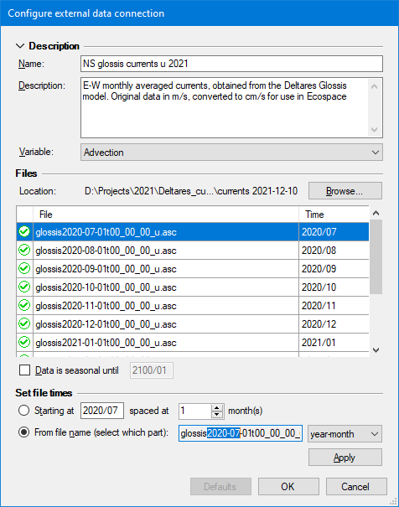
- Enter a name that identifies data content, keeping in mind that you may end up having a large number of connections to sift through. We recommend that you define a simple and consistent naming scheme that identifies the data content, its source, and spatial and temporal resolution, but NOT how you plan to apply it. For instance, a good name would be “GFDL-ESM4_global_1dd_ dphy_hist”.
- Enter a description to elaborate on data source, spatial and temporal resolution, data pedigree, and other details that you may find handy.
- Optionally, select the Ecospace variable the connection is limited to. This does NOT assign the connection; it only limits where this connection is available in the EwE user interface.
- Press Browse to select which files belong to the connection browse to the folder where the files reside, and select and insert the desired files. The files list will populate in response.
- Each file represents a map in time; the spatial temporal framework will try to decipher the map time stamp from its file name. If these defaults need changing, time stamps can be modified by hand, or through the “Set file times” section by either specifying a start date (year/month) and monthly interval, or by reading the time step from a fixed position in the file names. Seasonal data rotates the first year of data until the indicated end date.
Figure 3 - Configure external data connection screen, where users configure a time series of external maps
- Press OK

The Spatial Temporal Data Framework encapsulates two GIS data processing libraries, DotSpatial and GDAL, to translate spatial data from a wide range of formats to the ASCII raster format that Ecospace natively can access. This conversion occurs invisibly to the user. It is up to the user to outweigh the convenience of automatic data conversions with the risk of undesired GIS processing artefacts in resulting data.
We urge caution when using the automatic GIS conversion capabilities of the framework, and recommend performing GIS data transformations outside EwE to ensure a good understanding of the data that Ecospace will be ingesting, including GIS processing artefacts.
Note the that Spatial Temporal Data Framework will produce a log file with all activity in the same folder as the EwE model. This log can be consulted for all GIS operations that the Framework performed during model runs. The Framework also caches the result of GIS operations on the local machine, and employs reasonable intelligence to invalidate the cache when source data has changed. The EwE external data options (Menu > Tools > Options > External data) screen provides access to the GIS data cache.

Assigning external data to Ecospace
To make external connections operational in Ecospace, do the following:
- Go to Navigator > Ecospace > Input > External data… The external data view opens up (Figure 4), and displays all Ecospace map layers that can receive external data. The toolbar offers options to limit the number of layers on display, with filters by layer type, and only viewing layers with active connections. The external data interface also shows a time line that reflects the temporal overlap of external data with the Ecospace scenario.
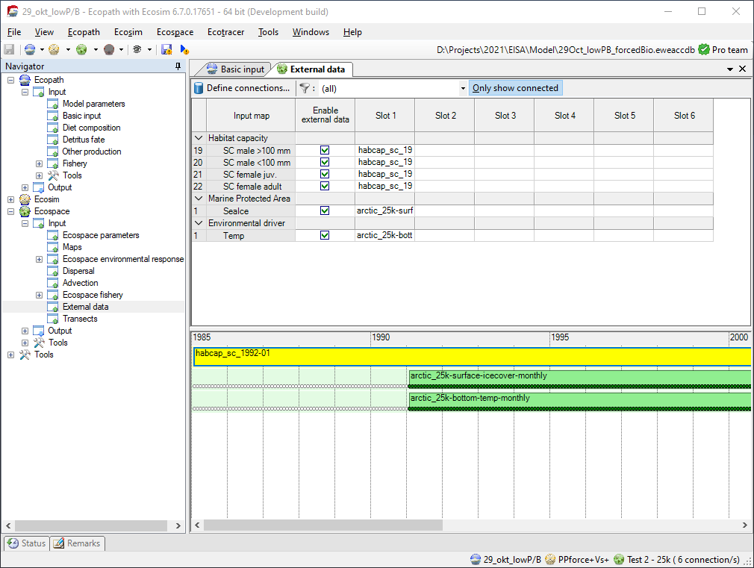
Figure 4 - External data view, which provides an overview which Ecospace layers have external data assigned to them.
To assign external data to an Ecospace map layer:
- Click the first available slot in the layer that you wish drive with external data. This opens up the “Assign connection” screen (Figure 5)
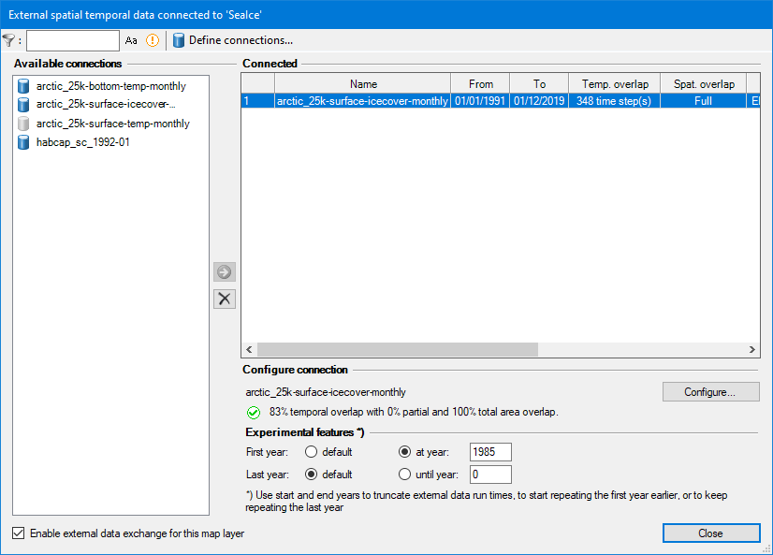
- Select a connection from the list of available connections and Click the use button () to assign the connection. The configure connection panel will show additional options if applicable.
- To de-assign a connection, select it on the right side and click the de-assign button ( ).
- Configure the connection. Available options depend on what was selected, and the type of Ecospace layer the connection is applied to. Some Ecospace layers may require data to be scaled, for instance, and for those layers you will need to provide a scalar. The configuration panel also summaries compatibility of assigned external data with the current Ecospace scenario.
Figure 5 - Assign connection interface, where an external data connection is assigned to the type of connection that a single Ecospace map layer.
- Click Configure to review or change the configuration of the connection (as explained above).
- Select an Integration method if applicable, which are geospatial macros that convert data to the desired Ecospace layer needs.
- Enter a scaling factor, which can be left at default 1 if data in the Ecospace scenario is the same as the first month of external data.
- Calculate the scaling factor to scale the first year of external data scales to an Ecopath base value (this is highly recommended when driving the Relative PP layer, for instance).
- Customize date range (new in EwE 6.7) if necessary to either limit or extend the time period that external data is applied to. Setting the applied data before the actual external data starting point will keep repeating the first year of external data until the actual data is encountered. Extending the date range past the actual last data point of the external data will keep repeating the last year of data. Extended data will show up as grey circles outside the spatial temporal bar (not depicted here).
- Press Close to make the external data connection stick, and save the model.

The “enter date range” feature was primarily added as a means to truncate the time span that external data is applied to, without having to edit the underlying external data connection. The feature can also be used to substitute known data for historical or future periods for which no map trends exist, but please use this only in those specific cases where using replacement data can be scientifically justified.

Running Ecospace with external data
When Ecospace is executed as normal, the EwE status panel will show a notification every time external data is accessed and whether integration into the intended Ecospace layer was successful. These notifications are also written to an extensive log file, which is written to the same directory where the EwE model is located. This file can be helpful for troubleshooting external data connection issues.
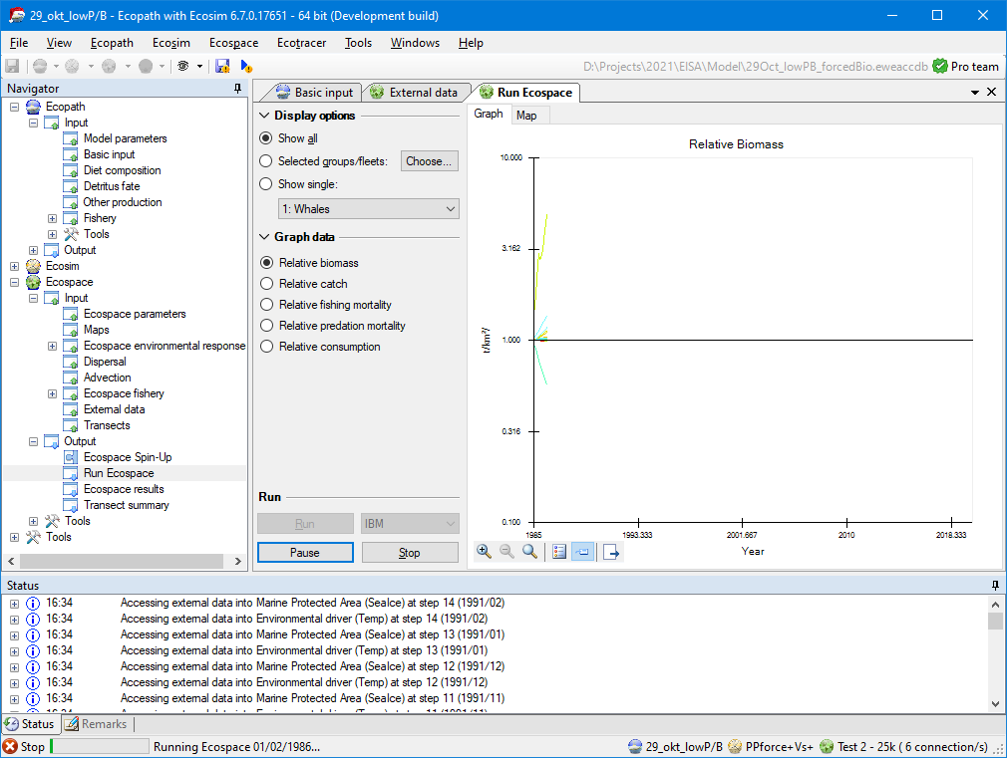Figure 7 - Run Ecospace interface and the EwE status panel. The status panel informs users when Ecospace has attempted to integrate external data into the running model
If Ecospace has encountered any issue with external data during a run, it will notify the user that issues were encountered. As the Ecospace run missed some needed external data it should not be trusted, and the status panel and/or spatial log file will provide clues as to why needed spatial data was not found.

Configuration files
All spatial temporal data connection definitions are stored in configuration files. At any given moment, EwE operates on only one configuration file that defines available external data connections. This central storage allows external connections to be reused between Ecospace modelling exercises, and provides a means to organize how much data is visible to a specific modelling exercise.
Configuration files are managed in Menu > Tools > Options > External data… Here, one can create or delete configuration files (in .xml format), add an existing configuration file to EwE, and set the active configuration file.
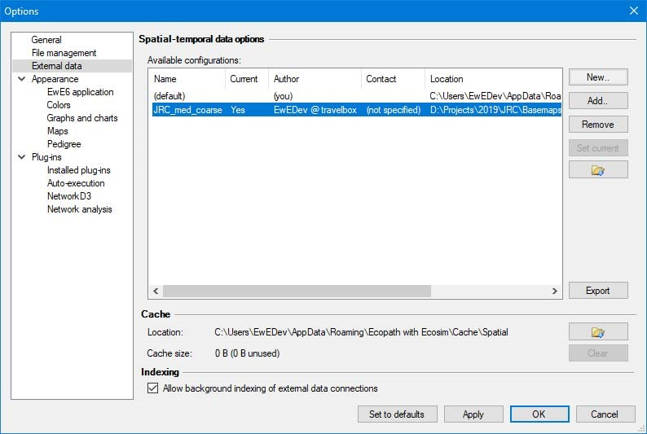
Figure 8 - The form where users can switch external data configuration files. Use this only when you run multiple projects at the same time, each requiring numerous external data connections
Once a connection is applied to an Ecospace layer, the definition of the connection is stored within Ecospace, while the data remains outside the model.
It is advisable to use separate configuration files for different models, as the number of external spatial temporal data connections can become overwhelming.

Sharing external data between computers
The export external spatial data interface, which can be launched from all locations in the EwE user interface where external data connections are managed, creates new configuration files from selected external data connection definitions, and optionally their data. All exported data is placed in a user-selected folder.
To share external data connected to your model with another computer or user:

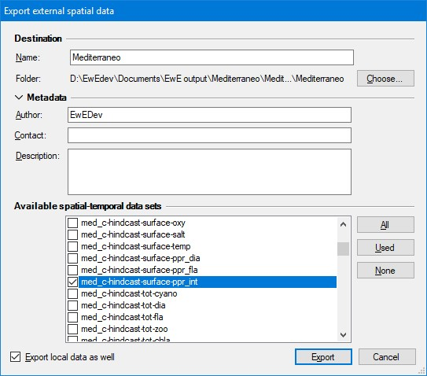
- Open the export external spatial data view, for instance through Menu > Tools > Options > External data > Export
Figure 9 - The Export external data interface
- Enter a descriptive file name (such as “External data Med 0.01667dd”)
- Select Choose to browse to the location where the exported data will be placed
- Select which connections to export. The “Used” button selects all connections assigned in Ecospace; the “All” button selects all available connections as defined the current configuration file.
- Check “Export local data as well”
- Click Export. Please be patient, this may take a while.
Once the export process is complete, share the data as follows:
- Give the entire exported folder with your model to another modeller. One can also place the exported folder on a shared network drive
To incorporate shared data into EwE:
- Go to Tools > Options > External data
- Click Add, and browse to the shared configuration file
- Press Open and the configuration file will be added to EwE
- Press “Set Current” to make this the active configuration file
- Load Ecospace. When an Ecospace scenario is loaded, the spatial temporal data framework automatically resolves conflicts in external data connections against the current configuration file.

References and background information
Christensen, V., and Walters, C.J. (2004). Ecopath with Ecosim: methods, capabilities and limitations. Ecol. Model. 172, 109–139.
Heymans, J.J., Coll, M., Link, J.S., Mackinson, S., Steenbeek, J., and Christensen, V. (2016). Best practice in Ecopath with Ecosim food‐web models for ecosystem‐based management. Ecol. Model. 331, 173– 184.
Steenbeek, J., Coll, M., Gurney, L., Mélin, F., Hoepffner, N., Buszowski, J., and Christensen, V. (2013). Bridging the gap between ecosystem modelling tools using geographic information systems: driving a food‐web model with spatial‐temporal primary production data. Ecol. Model. 263, 139–151.
Steenbeek, J., Buszowski, J., Christensen, V., Akoglu, E., Aydin, K., Ellis, N., Felinto, D., Guitton, J., Lucey, S., Kearney, K., et al. (2016). Ecopath with Ecosim as a model‐building toolbox: Source code capabilities, extensions, and variations. Ecol. Model. 319, 178–189.

